Welcome December 2021

Our 2b pupils loved creating their very own Advent calendar. Hand sewn Christmas stockings is always a favourite festive activity and makes the countdown to Christmas even more special.

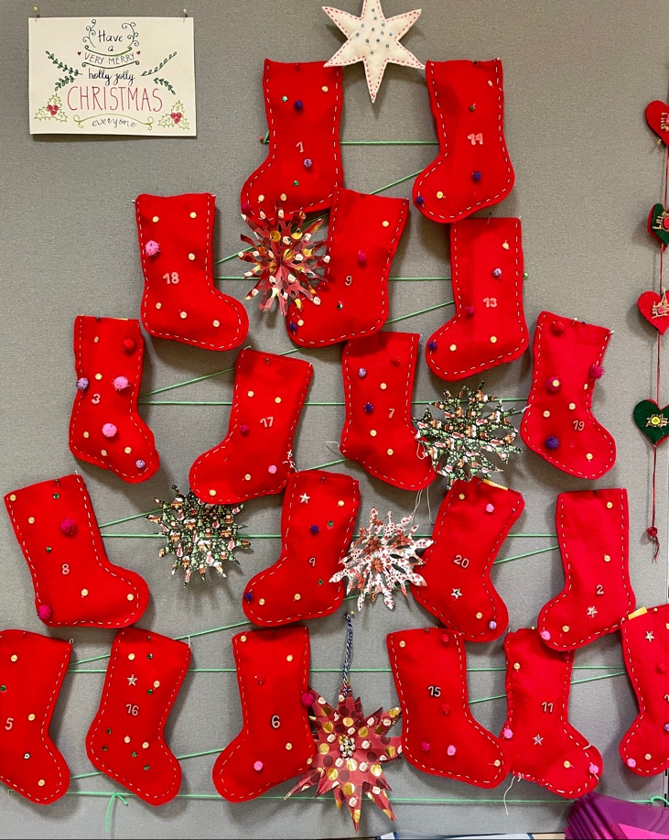

For some of us, Christmas isn’t the same without reading the Nutcracker classic fairy tale, a well illustrated book written by author, Jane Ray. The music is such a fascinating piece, every pupil should be able to recognise it. After reading the fairy tale, the pupils enjoyed the process of crafting a nutcracker and a ballerina snowflake, whilst enjoying a glass of Christmas punch!

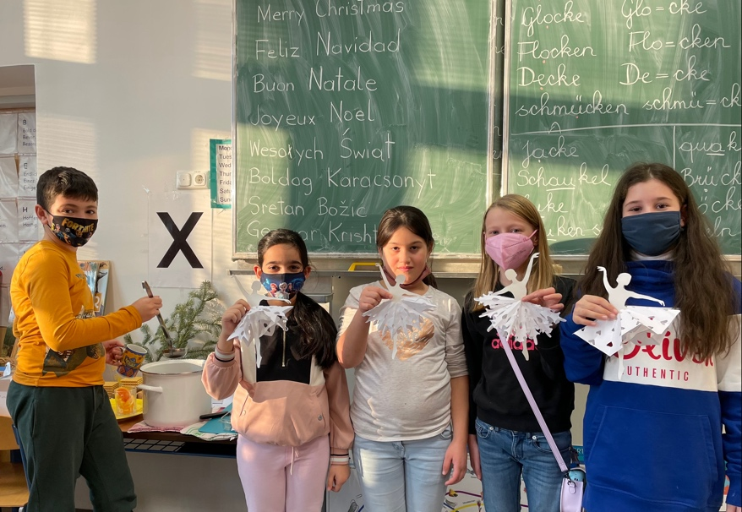

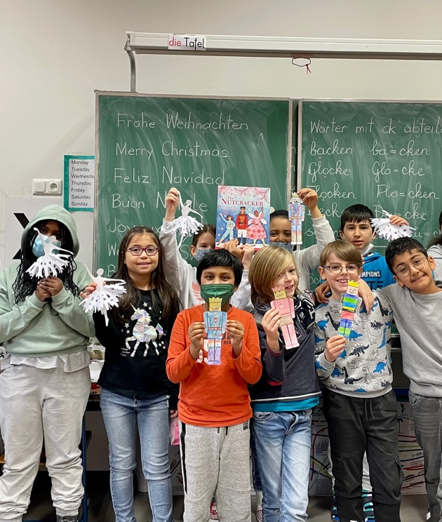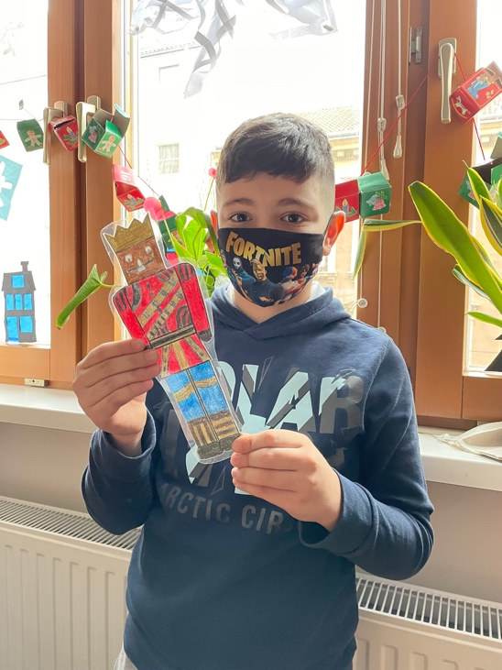

During the festive season, we have been reading several story books, namely, Santa Got Stuck, The Nutcracker, How the Grinch Stole Christmas, Snowflake in my Pocket, the Gingerbread Man and several others. Pupils enjoy storytelling and we look forward to exploring new adventures on new pages in the New Year.

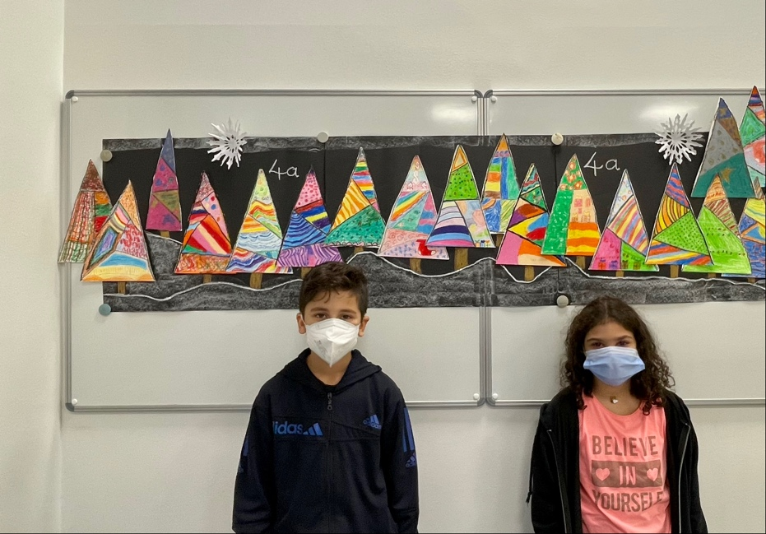

The 4a pupils loved creating these adorable and colourful Christmas trees. May they continue to excel at art lessons!
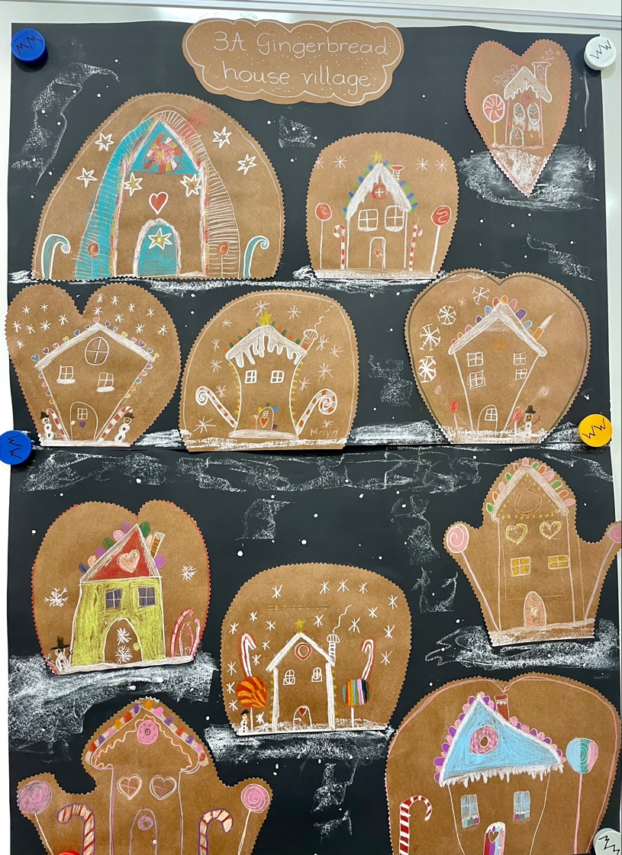

Gingerbread houses are iconic at Christmas time! Our pupils have thoroughly enjoyed the process of creating them.

We would like to take the opportunity to wish you and your loved ones a peaceful Christmas and a New Year filled with good health and happiness!

